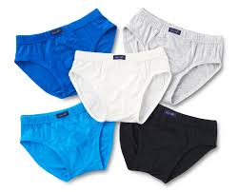
CLOTHERS WE WEAR (UNDERWEAR) IMAGES

